**Table of Contents**

1. **Integrating tapCLIQ Android SDK**
2. **Requesting Tag Based Ads**
3. **Listening to Question-Answer Ads**
4. **AdBarListener**
5. **My Wall**
6. **Push Notifcations**
7. **Integrating tapCLIQ Android SDK**

**Note: For Android Studio – use tapCLIQsdk.aar and integrate it in your app as shown below**

* 1. At the top level in project structure of your app – import .aar package as show in the screen shots below
  2. Select .aar package downloaded on your computer and click Finish. Package will be added to your app.

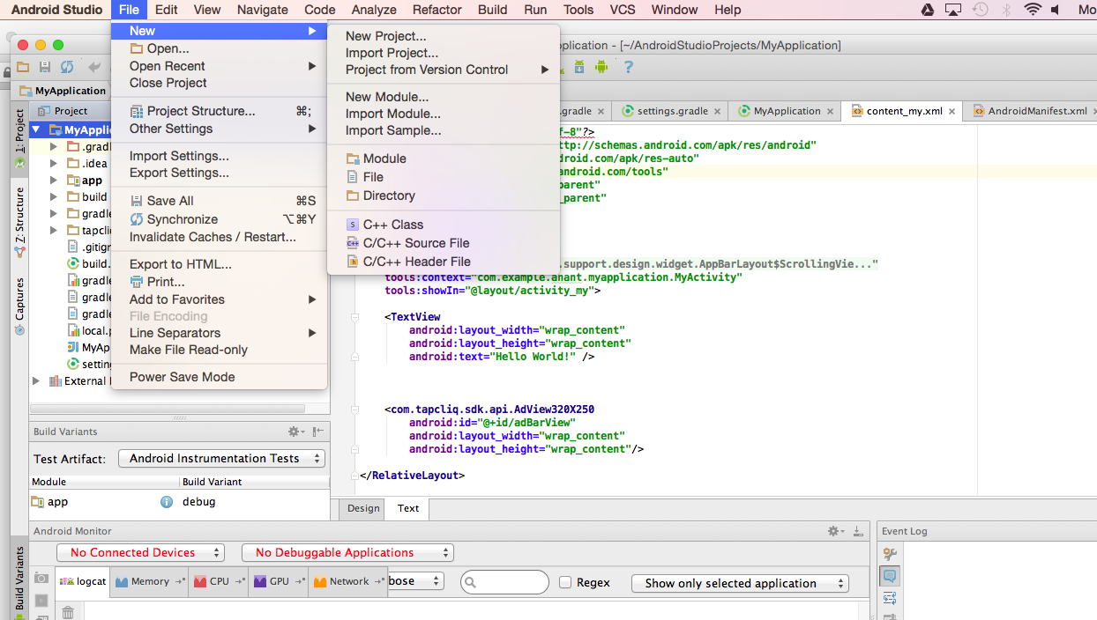

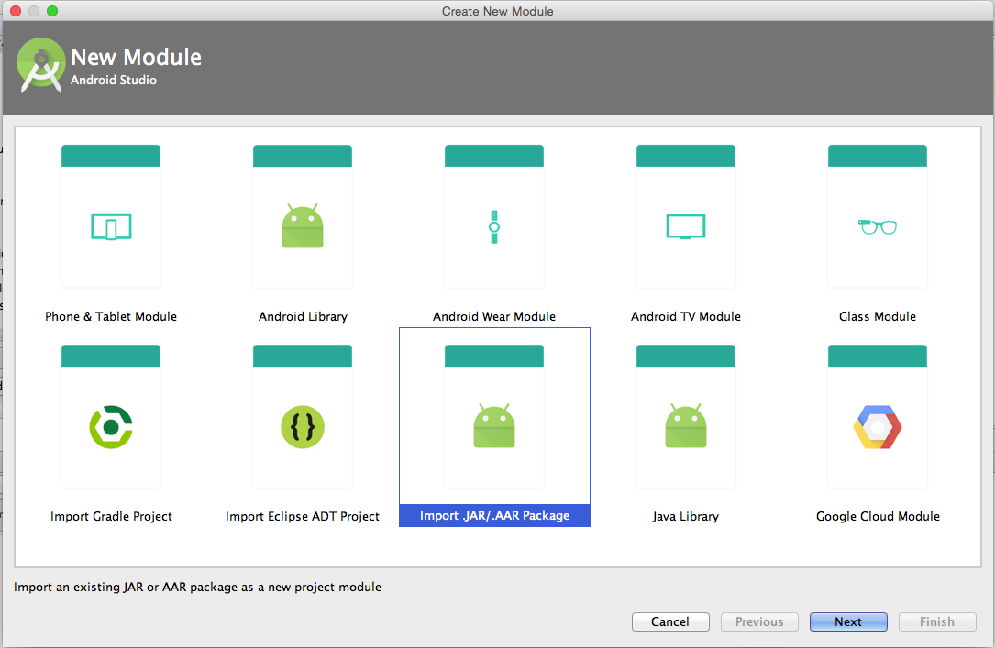

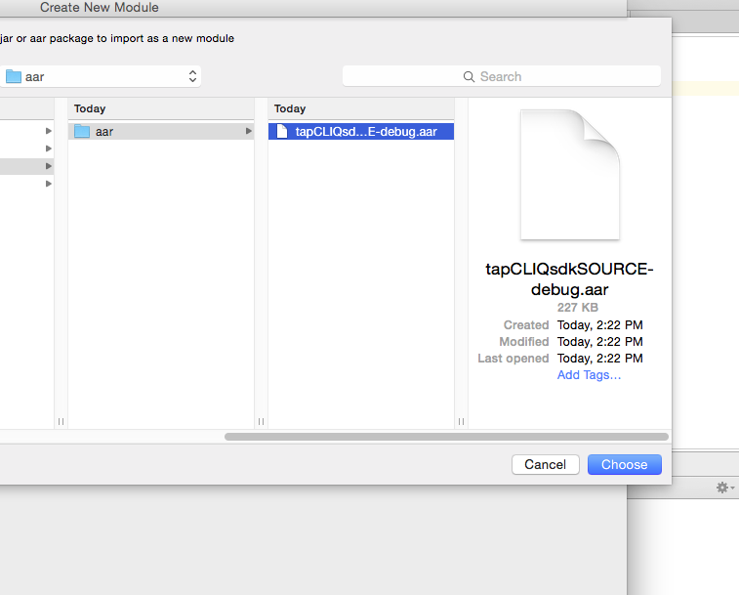

**Step 3:** Configure your Manifest file

* 1. On your applications manifest file add the following permissions:

<!-- Used to download the ads -->

<uses-permission android:name=*"android.permission.INTERNET"* />

<!-- Necessary to check if the device is connected to a network -->

<uses-permission android:name=*"android.permission.READ_PHONE_STATE"* />

<uses-permission android:name=*"android.permission.ACCESS_NETWORK_STATE"* />

<!-- Used for displaying maps and getting location based ads -->

<uses-permission android:name=*"android.permission.ACCESS_FINE_LOCATION"* />

<uses-permission android:name=*"android.permission.ACCESS_COARSE_LOCATION"*/>

1. Add the Call For Action Activity

<activity

android:name=*"com.tapcliq.sdk.api.ActivityCFA"*

android:theme=*"@android:style/Theme.Translucent.NoTitleBar"*

android:noHistory=*"true"*>

</activity>

***NOTE: If you application uses fullscreen attribute, change the theme to this:***

android:theme=*"@android:style/Theme.Translucent.NoTitleBar.Fullscreen"*

**Step 4:** Add an Ad View to your layout file

1. For new 300 x 250, or 300 x 600 or 720 x 300 unit

<com.tapcliq.sdk.view.AdView  
 android:id="@+id/webAdView"  
 android:layout_width="wrap_content"  
 android:layout_height="wrap_content"  
 android:visibility="visible"

"/>

1. Other Views you can add include:

com.tapcliq.sdk.api.AdView320X240

com.tapcliq.sdk.api.AdViewFullScreen

com.tapcliq.sdk.api.AdViewWidthX90

com.tapcliq.sdk.api.AdView320X250

**Step 5:** Instantiate the Ad View in your activity

1. In your activity create an instance of the AdView

**private** AdView mWebAdView;

1. Instantiate and start showing ads; make sure you pass in your appId and unitId. The app id and unit id can be found in your account at tapcliq.com. Click the tab “My Apps” find your application.

**For web ads:**

**mWebAdView** = (AdView) findViewById(R.id.***webAdView***);  
**mWebAdView**.showNewAd(**"a7380cf91c5347b688ea351c5d78157q"**, **"PU"**, **"testandroid"**);

*// 1st Parameter is App ID for your registered app,*

*// 2nd Parameter is “PU” for 720 x 300, “MR” for 300 x 250, “HP” for 300 x 600, “R” for 320 x 50*

*// 3rd Parameter is a string tag for which ads will be fetched (you can specify multiple tags by separating them with comma)* **mWebAdView**.setBackgroundColor(Color.***TRANSPARENT***);  
 **mWebAdView**.setVisibility(View.***VISIBLE***);

**For native 320x50 ads:**

mAdBarView = (AdView320X50) findViewById(R.id.*adBarView*);

mAdBarView.showAd("Your App ID Goes Here", “Your Unit ID Goes Here”);

1. In the activity’s onDestroy method make sure you add the following:

@Override

**protected** **void** onDestroy() {

mAdBarView.destroy();

**super**.onDestroy();

}

Whenever you wish to display / request ad call showNewAd and set visibility:

**mWebAdView**.showNewAd(**"a7380cf91c5347b688ea351c5d78157q"**, **"PU"**, **"testandroid"**);

**mWebAdView**.setBackgroundColor(Color.***TRANSPARENT***);  
 **mWebAdView**.setVisibility(View.***VISIBLE***);

**NOTE: You do not need to do anything else if you just want to integrate ad unit. For push notifications and in-app message wall read futher**

1. **Requesting Tag Based Ads for native 320 x 50 unit**

You can request tag based or moment specific ads. These tags are specified when creating a campaign in your tapcliq.com dashboard. Any ad that matches your tag will be displayed (you can have multiple). To do this you just have to call the following method:

mAdBarView.requestTagBasedAd(“your tag”);

*Example:*

Triggering an ad that matches the tag "coffee," would be done by passing the tag as follows:

mAdBarView.requestTagBasedAd(“coffee”);

If you want stop receiving the tag based ads, just pass in **null**:

mAdBarView.requestTagBasedAd(**null**);

1. **Listening to Question-Answer Ads**

Every answer your users give with a Question-Answer ad can be handled within your app. Listening to the answers your users give allows you to better adapt your app to what they want. When you create a Question-Answer ad, make sure you add a tag to each possible answer. This tag is what you will use to identify what answer your user gave. In order to listen to these answers, you must create an AdBarListener as shown below:

mAdBarView.setAdBarListener(**new** AdBarListener()

{

Override

**public** **void** onAnswerSelected(String answerTag)

{

//Handle answers here!

}

… More methods

})

1. **AdBarListener**

Apart from listening to the answers your users give, the AdBarListener has various other callbacks. Below is a list of all the current events that are available:

mAdBarView.setAdBarListener(**new** AdBarListener() {…});

|  |  |
| --- | --- |
| **AdBarListener methods** | **Purpose** |
| **onNewAdPacketRequested()** | Called when a new ad packet has been downloaded and ready to display |
| **onAdBarDisplayed()** | Called when the first ad is shown. This is when the ad view becomes visible |
| **onAdBarRemoved()** | Called when the ad view is removed and therefore not visible anymore. This is usually because there are no more ads to be displayed |
| **onAdChange()** | Called when a new ad is displayed |
| **onCFAOpened()** | Called when the user has interacted with the ad and therefore opened the call for action activity |
| **onCFAClosed()** | Called when the call for action activity has been closed |
| **onAnswerSelected(String answerTag)** | Called when the user has selected an answer to a Question-Answer ad (answerTag is the tag associated with the specific answer) |
| **onEmptyPacket()** | Called when there were no ads found. 1) There are either no ads linked with your app id. 2) There are no ads with the requested tag. 3) There is no network |
| **onError(String error)** | Called whenever there was an error retrieving the ad packet. The string error is the error returned by the server |

1. **My Wall**

My Wall allows you to interact with your users in a more personal way. Users can send feedback, ask questions and view your replies. To open the users My Wall use the following static method:

MyWall.*loadMyWall*(activity, "Your App ID Goes Here");

1. **Push Notifications**

Push notifications are a great way to easily notify all your users right away. In order to enable push notifications on your app add the following to your manifest file:

1. Permissions:

<!-- Push notifications -->

<uses-permission android:name=*"android.permission.GET_ACCOUNTS"* />

<uses-permission android:name=*"android.permission.WAKE_LOCK"* />

<uses-permission

android:name=*"com.google.android.c2dm.permission.RECEIVE"* />

<permission

android:name=*"com.tapcliq.sdk.gcm.permission.C2D_MESSAGE"*

android:protectionLevel=*"signature"* />

<uses-permission

android:name=*"com.tapcliq.sdk.gcm.permission.C2D_MESSAGE"* />

1. Add the following inside your <application/>

<application

<meta-data

android:name=*"com.google.android.gms.version"*

android:value=*"@integer/google_play_services_version"* />

<receiver android:name=*"com.tapcliq.sdk.gcm.GcmBroadcastReceiver"*

android:permission=*"com.google.android.c2dm.permission.SEND"* >

<intent-filter>

<action

android:name=*"com.google.android.c2dm.intent.RECEIVE"* />

<category android:name=*"com.tapcliq.sdk.gcm"* />

</intent-filter>

</receiver>

<service android:name=*"com.tapcliq.sdk.gcm.GcmIntentService"* />

</application>

1. Add google_play_services library to your project

**Step1**: Find the google_play_services library wherever you have your android sdk folder

androidSdk/extras/google/google_play_services

**Step2**: Import it to your workspace

File > Import > Android > Exiting Android Code into Workspace

**Step3**: Add the library to your app

Right click on your project > select Properties > select Android on the left > at the

bottom click on add and select google_play_services